Next Sunday, the church will be celebrating Palm Sunday. For many of us, we have been celebrating with a Palm Parade for as long as we can remember. This year, we are not going to be able to celebrate in the traditional way. So, we are asking that you help us to create a virtual Palm Parade. Over the next 2 days, I would like to collect as many photos as possible of folks holding palm branches (or a reasonable facsimile). Or, you can paint some palm branches and hosannas on your windows!

PALM BRANCH FACSIMILES:

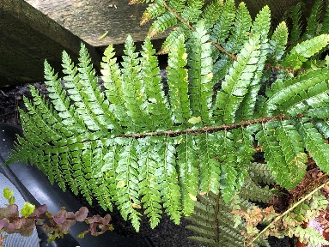
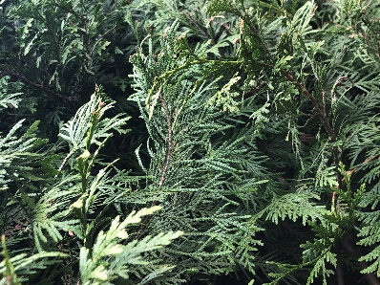
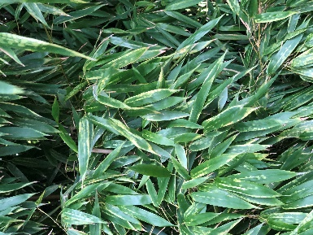

BAMBOO CEDAR FERN

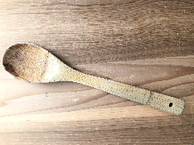
Or you can make your own…

SUPPLIES:
green paper (or white paper painted or coloured green; tissue paper; newspaper)
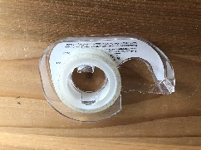
Wooden Spoon (or chopstick; popsicle stick; stick from the garden)
Scotch Tape
Pen (or pencil; crayon)
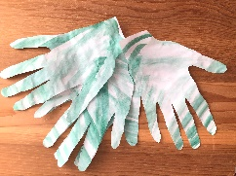
Scissors

1. Find or create green paper… if you paint it, wait till it dries for step 2…
2. Trace your hand onto the green paper…
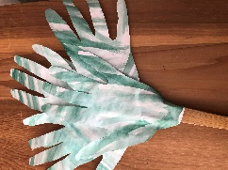
3. Cut out the hand shapes
4. Tape the hand shapes to the wooden spoon (stick)

Next, take a picture of yourself with your palm branch…
all the photos will be used in our worship online so if you would prefer
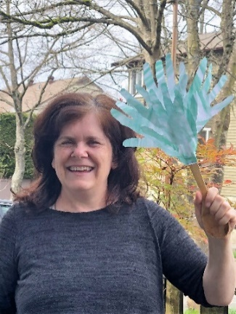
just a picture of your hand holding the palm branch that would be great.
(We would love lots of smiling faces in the parade but we also
understand people’s need for privacy if necessary).

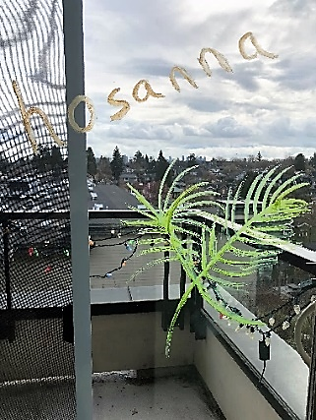

with face sample

Email your favorite photo(s) to
INSERT YOUR CONTACT INFORMATION HERE!
without face sample

Deadline for sending photos is INSERT TIME AND DATE

